|  |  |
| --- | --- |
| ID | JM_002 |
| Test Case Name | Search load testing |
| Objective | Verifies peak NY Times load of 1000 users searching the same product. |
| Test Scenario | 1. Create Thread Group  2. Enter 1000 for number of threads  3. Enter 10 Sec for ramp-up period  4.Create HTTP Request Sampler  5.View Results tree  6. Graph Results  7.View Results In Table  8. View Summary Report |
| Input | Number of threads (users).  Ramp up period.  Server URL/Path.  Product code to search on |
| Expected output | The searching for the same product of all 1000 users at the same concurrent time |
| Actual output | The searching for the same product of all 1000 users at the same concurrent time |
| Pass/Fail | Passed |

View Results tree:

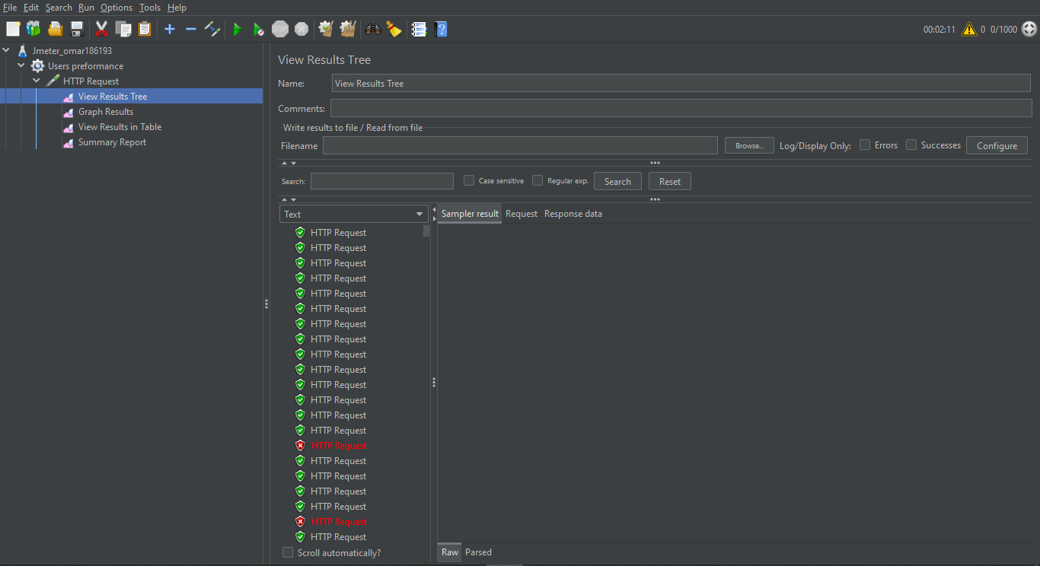

Graph Results:

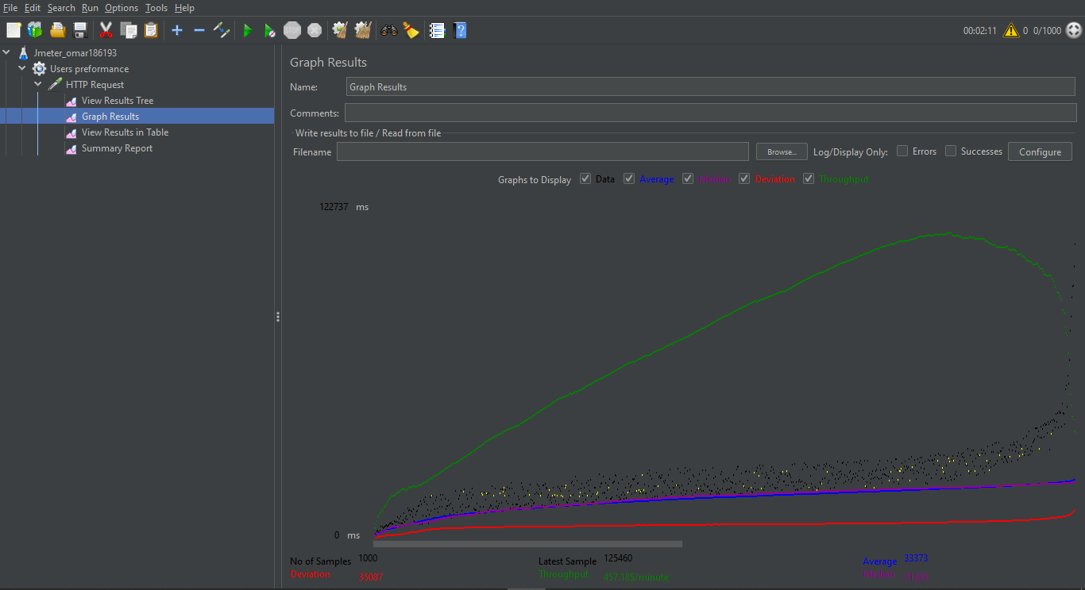

View Results In Table :

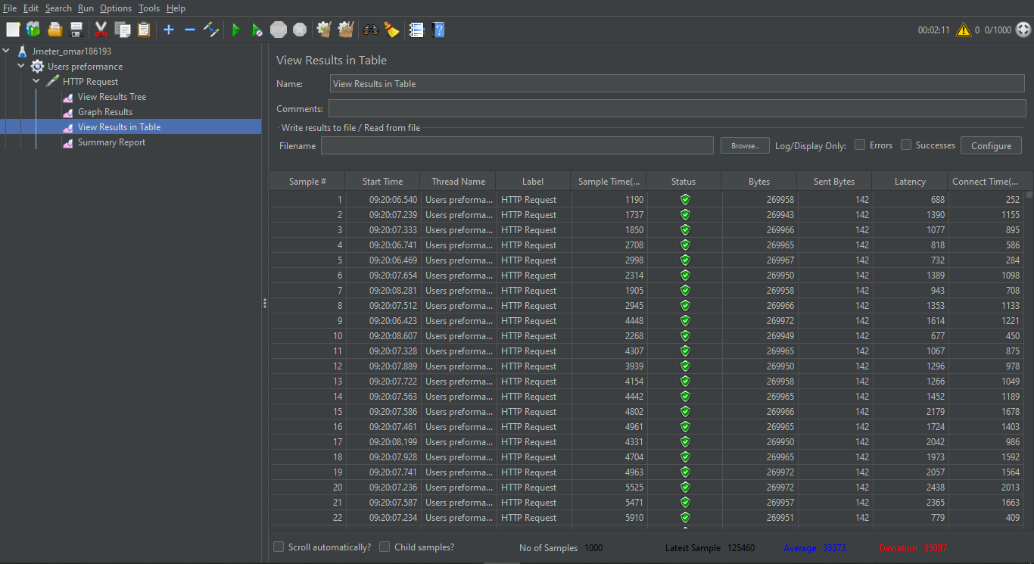

View Summary Report :

